**Understanding ADHD: Challenges and Strengths**

Created by Carolyn Cahn, Certified Coach, Registered Nurse

This information sheet aims to shed light on some of the negative and positive aspects of living with ADHD.

**What is ADHD?**

**A**ttention **D**eficit **H**yperactivity **D**isorder (ADHD) is a neurodevelopmental disorder. It can bring both challenges and strengths to those who have it. While some people are diagnosed in childhood, there are many who do not learn about their ADHD until they are adults. When diagnosed with adult ADHD, a person can gain an understanding of some of the challenges they may have experienced in various areas of their life.

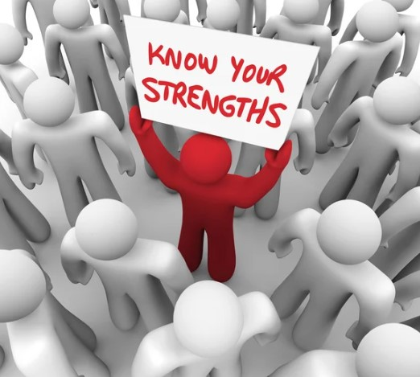

# Negative Challenges

Inattention causes difficulty staying focused on tasks which creates difficulty completing projects and school or work assignments in a timely manner.

Forgetfulness and disorganization such as frequent misplacing of car keys or glasses

Academic and job challenges cause lower grades and/or poor performance in school or work.

Time management and meeting deadlines affect many areas of life.

**Examples of negative behavior:**

John always drives 90 miles per hour (mph) in a 55-mph zone.

Mary often spends her entire paycheck at the race tract and then uses a credit card for placing more bets.

Jose is always more than 15 minutes late for any meeting or event, no matter how important. He has already been fired from three jobs.

Jen argues with her husband about every decision, even when it is not an important issue.

# Positive Strengths

Creativity and the ability to multitask can assist in work and other areas of life.

Flexibility and the ability to manage multiple responsibilities is very useful in many roles.

ADHD individuals often exhibit creative thinking and problem-solving skills.

Innovative ideas and unique perspectives.

Ability to hyperfocus on areas of interest creating a higher level of productivity.

High levels of energy and enthusiasm can be valuable in many arenas.

When doing something they enjoy they can excel in fast-paced environments.

Willingness to take risks and try new things can be a valuable asset in areas like sports, certain job roles, and more.

High energy and motivation and determination.

Resilience, especially due to past challenges that required adaptability and coping skills.

# Conclusion

Understanding the complex aspects of ADHD can help individuals with ADHD as well as their friends, family, and educators identify strategies to harness their strengths and address their challenges. With the right support and resources, individuals with ADHD can lead fulfilling lives.



Ready to conquer ADHD challenges and achieve your goals? Carolyn, a certified coach with years of ADHD mastery, is here to guide you. Whether it's personal growth or workplace success, she's your partner in transformation. Don't wait; start your journey now!

**Book a free 15-minute consultation at Carolyncahn.com**.

**Disclaimer: This information sheet is for educational purposes. It is not a diagnostic tool and is not a substitute for professional medical advice. If you have any questions or concerns, please consult a healthcare professional for a proper diagnosis and management of ADHD.**